**DIFFERENTIAL PAIR OPAMP**

**Single ended differential op amp**

**Measure signal between wire and ground**

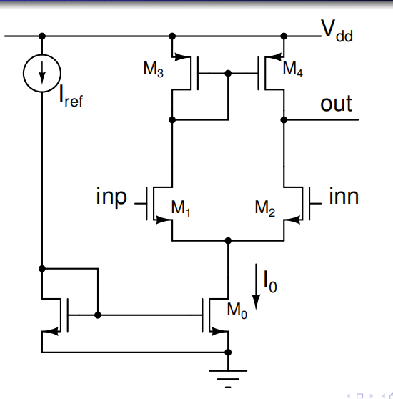

**Cascade output resistance**

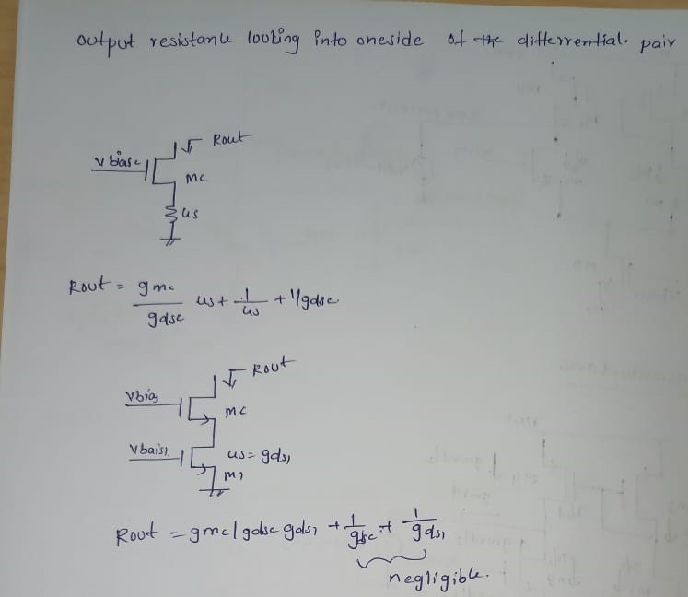

**Differential pair:Quiescent condition**

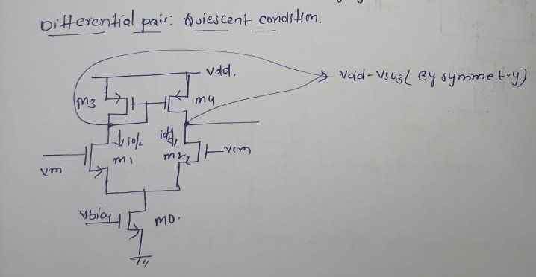

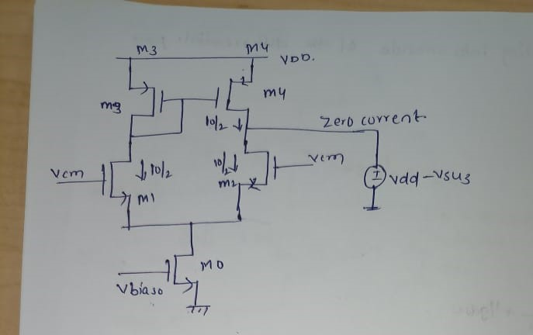

**Differential pair:Trans conductance**

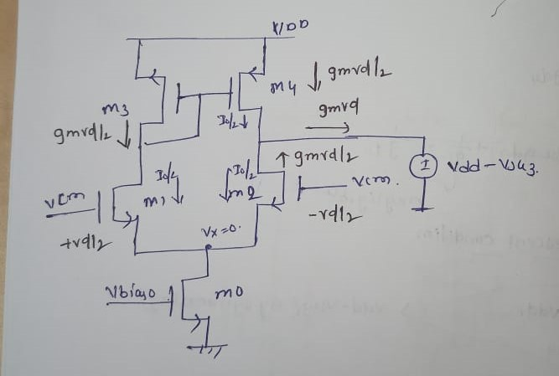

**Differential Pair:Output conductance**

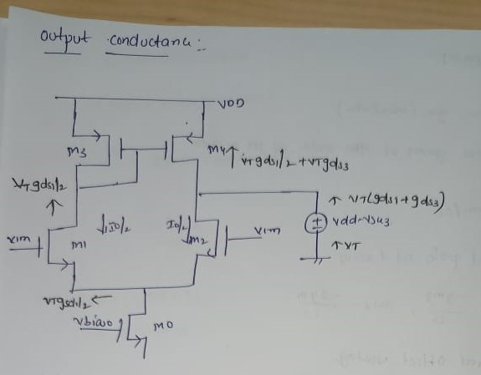

**Differential Pair:Noise**

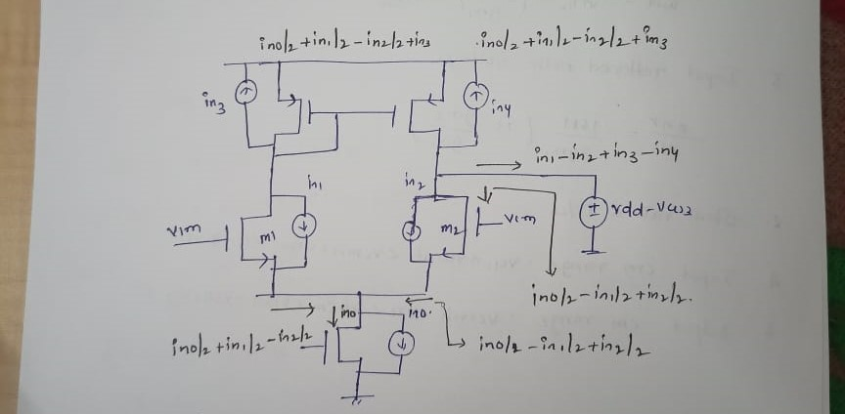

* **Carry out small signal linear analysis with one noise source at a time**
* **Add up the results at the output(current in this case)**
* **Add up corresponding spectral densities**
* **Divide by gain squared to get input referred noise**

**Differential pair opamp**

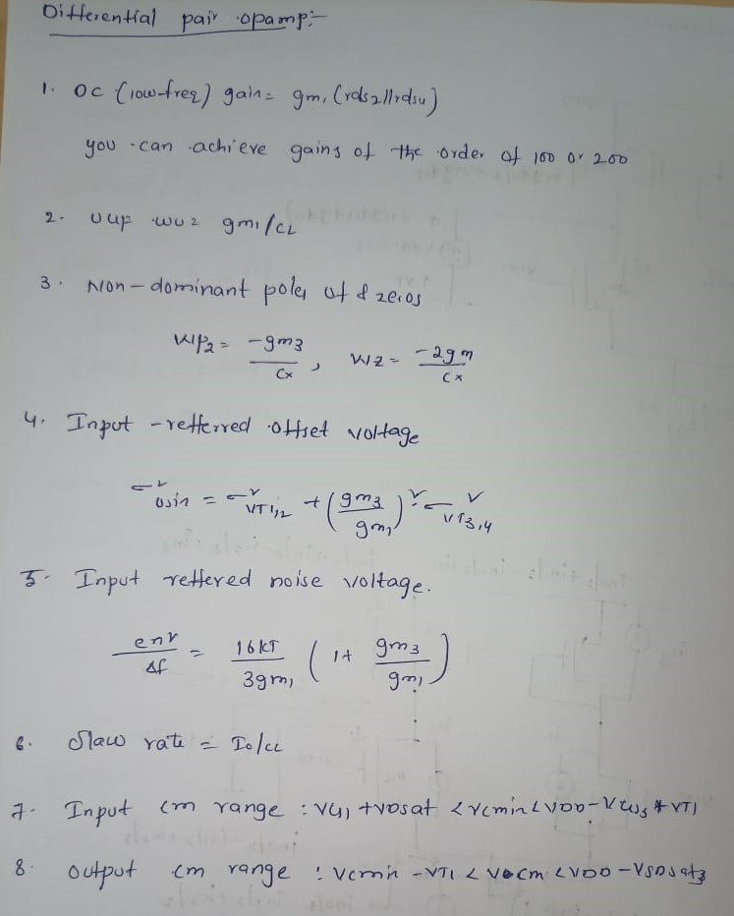

**Specifications:**

**Gain=50db**

**GBW=5M**

**SR=1v/microsec**

**CL=1pf**

**µp=120micro**

**µncox=350micro**

**Calculation:**

*SR=1v/micro sec*

*Sr=i0/cl*

*10^6=i0/10^-12*

**i0=1micro sec**

*Gain Band width=5MHZ*

*f=5MHZ*

*W=2π 2π*5*10^6=31.415*

*gm1=31.415*10^6*10^-12*

**gm1=31.415*10^-6**

*gm1=µncox (W/L) (vgs-vtn)*

*(W/L)=µncox(vgs-vtp)/gm1*

*=350*10^-6 (0.2)/31.415*10^-6*

gm1=2.22

*(0r)*

*gm1=√µncox (W/L)2id*

*gm1=√350micr0*(W/L) 2*0.5micro*

*(31.416*10^-6)^2=350micr0*2*0.5micro*

*L=1*

*(W/L)=2.8182*1*

*=2.8182*

*Here all mosfet for same length ‘L’=4*

*(W/L)1,2=2.8182*

*/4*

*gm3=gm1*

*gm3=√µpcox (W/L)2id*

*gm3= √120micr0*(W/L) 2*0.5micro*

*(31.416*10^-6)^2=120micr0*2*0.5micro*

*L=1*

*(W/L)=8.221*1*

*(W/L)3,4=8.2215/4*

*ID=1/2*µncox*(W/L)*(vgs-vtn)^2*

*Hera=vgs-vtn=0.2*

*1*10^-6=1/2 350micro(W/L)*(0.2)^2*

*L=2*

*(W/L)0= 0.1428*2*

*=0.284*

*(W/L)0=0.284/4*

*Assuming vtn=0.5*

*Vgs1-vtn=0.2*

*VGS1=0.7*

*Vds=0.7-0.5=0.2*

*Vsg-|vtp|=0.2*

*VSG3=0.7*

*VSG1+VDS<Vbias<(VDD-VSG3)+vtn*

*0.7+0.2<Vbias<(1.8-0.7)+0.5*

*0.9<Vbias<1.6*

*VGS1-vtn<vout<VDD-vdsat*

*0.7<vout<1.8-0.2*

*0.7<vout<1.6*

*GM=iout/vin*

*=gm1(rds1//rds3)=100v/v*

*(rds1//rds3)=100/31.415*10^-6*

*=3.183*10^6*

*Nmos=3.183*10^6+ pmos=8.5*10^6*

*=11.863*

*Rds1=1/λ*id*

*λ=1/rds1*id*

*λ=1/11.863*10^6*0.5*

*λ=0.15*

**I made the design in It spice:**

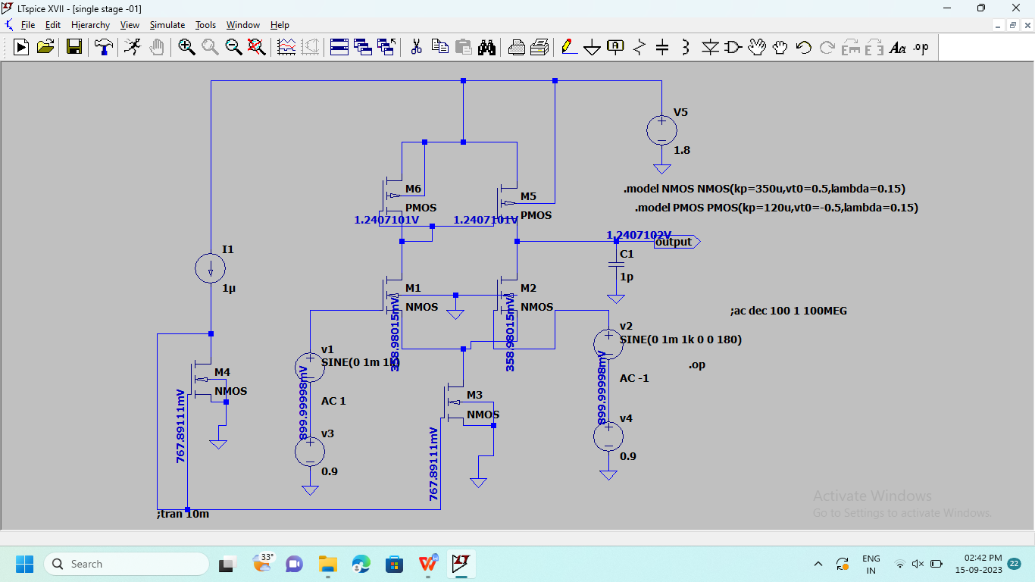

***DC outputs***

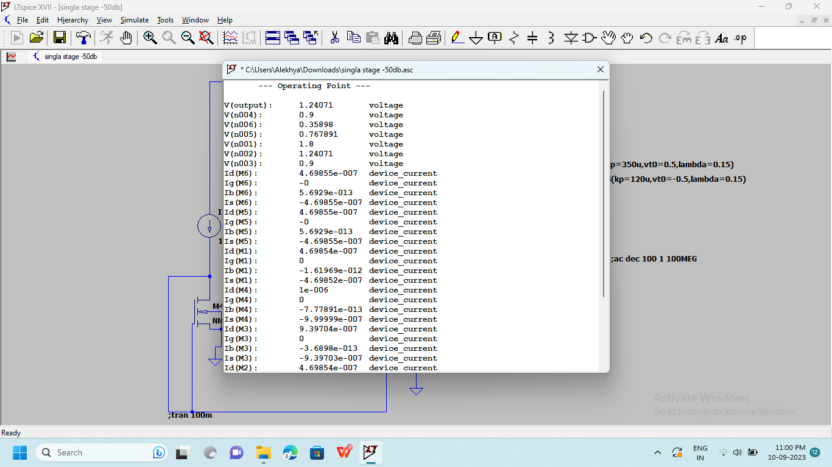

***V OUTPUT:***

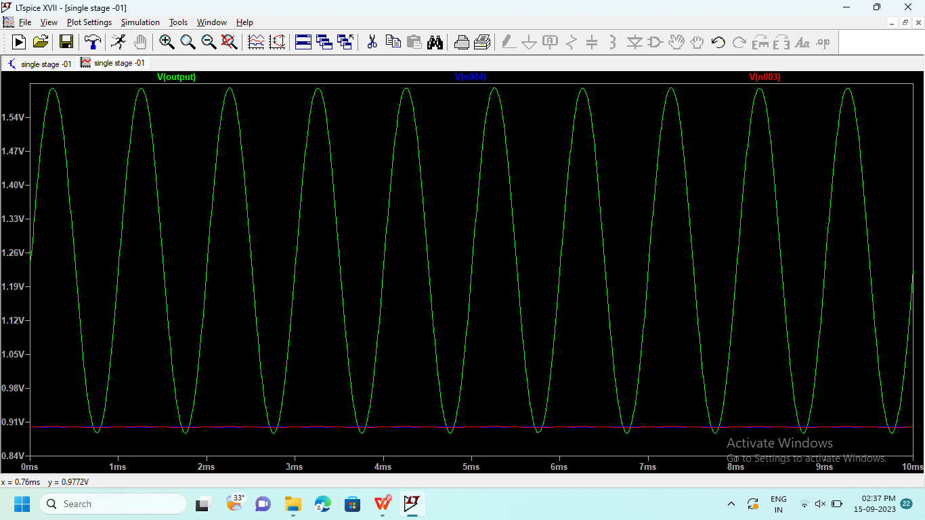

***Here above the graph we can this that input voltage is very lower and output voltage is very higher,clearly it is amplify.***

***Differential voltage(v3-v4)***

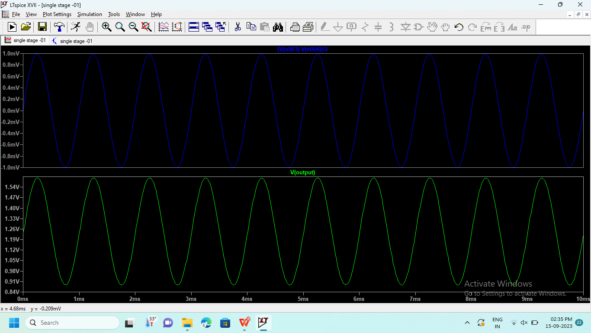

Output

voltage

Input voltage

***Transient Analysis:***

***713/2=356.5 max output amplitude waveform***

***Max input amplitude waveform 1m***

***365.5/1=356.5***

***log(365.5)*20= 51***

***Gain 50***

***Finally I am design an amplifier***

***Frequency response***

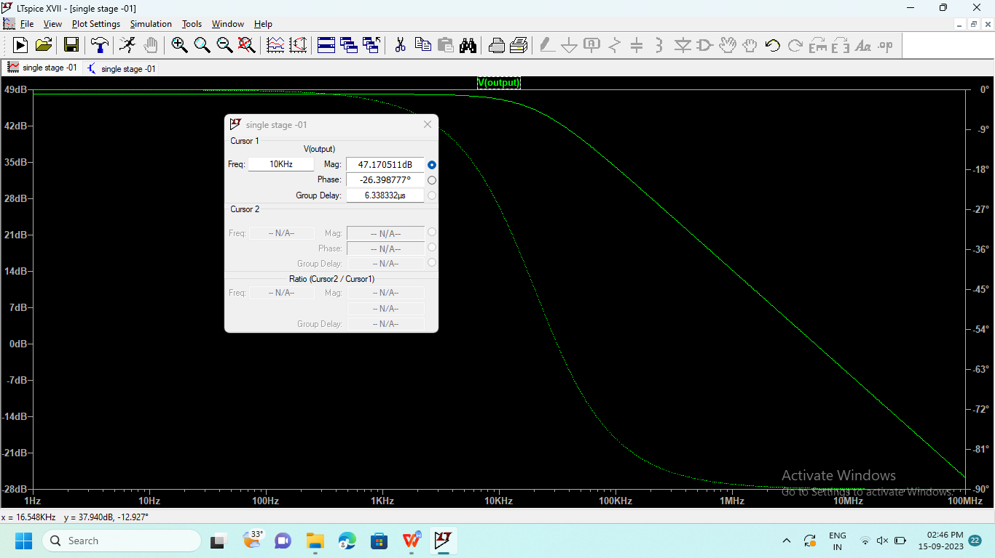

***I get gain as 47***

***Gain Band Width (near 0 db)***

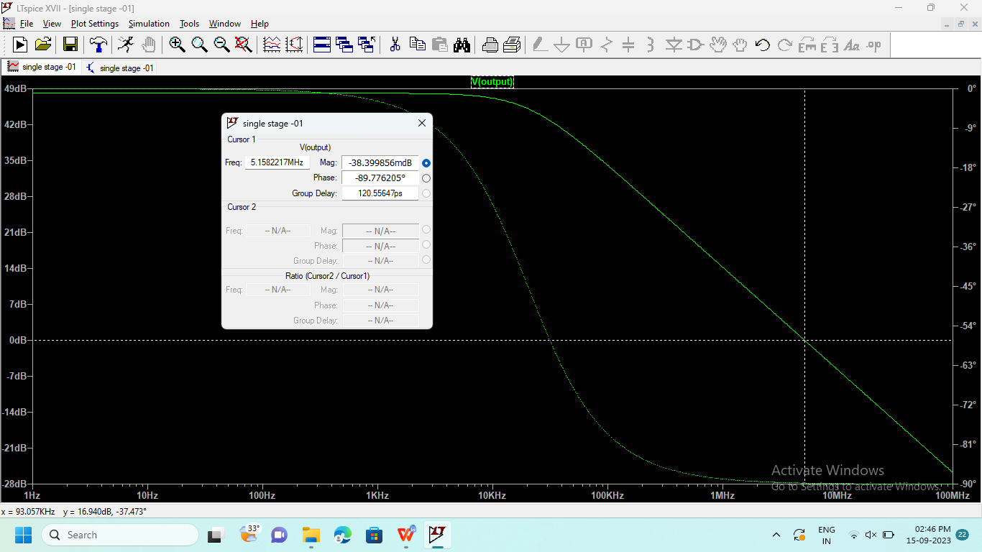

***Near 0db finally I got 5MHez***